|  |  |
| --- | --- |
|  | **BAHRIA UNIVERSITY,**  **(Karachi Campus)**  *Department of Software Engineering*  **Quiz # 03 – Fall 2023 [CLO 3]** |

COURSE TITLE: **Formal Methods in Software Engineering** COURSE CODE: [**SEN -**](http://moodle.bimcs.edu.pk/course/view.php?id=291) **323**

CLASS: **BSE – 5B** SHIFT: **Morning**

INSTRUCTOR: **Engr. Ammarah Khalid** DATE: **20th DEC 2023**

MAX. MARKS: **10 Marks** TIME: **20 Mins**

**STUDENT NAME: __________________________ REG # ________________**

**QUESTION # 01:** Represent the following statements in PTL?

1. *“In the next moment in time, ‘running’ will be true and, at some time after that, ‘terminated’ will be true.”*
2. *if, whenever I am happy, I will certainly be happy on the next day, then, if I am happy now, then I will always be happy in the future.*

1. *“if I am sleeping from now up until the time the alarm goes off and continue sleeping up until my doorbell rings, then I am sleeping from now up until the time my doorbell rings.”*

**QUESTION # 02:** Identify which the following are not legal wff of PTL:

1. r ∨ $◯$ ((p W q))
2. (￢p∧ ￢d) W (￢d)
3. $¬$ ◊d $↔$ $⎕w$
$￢(p ∧ ◯q)$

4. $◯$ p ∧ q( ◊ r)

**QUESTION # 03:** Construct a Non-Deterministic Büchi Automata (NBA) for the following language represented by the ω-regular expression:

100(001)ω + 0ω

**QUESTION # 04:** Consider the following trace and check which modal formulas and true and which are false

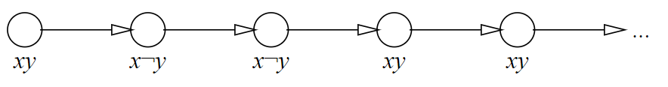

1. **XX** y
2. x ∨ ¬y
3. **G** y
4. **X** (y **U** ¬x)

**QUESTION # 05:** Which of the following is not a valid trace in the following transition system?

